**Name:**

theFootballers

**Title:**

Analysis of the Most Valuable Football Players in the World

**Team Members:**

Benji Hawkins, David Seger, Rachidi Ndongala

**Project Description:**

In this project, we are going to analyze and compare some of the best/most valuable football association players in the world. The group has a shared interest in football, so this topic was a natural choice. Through this, we want to create a website that can serve as a visual resource for soccer fans to find out more about their favorite players.

**Data Source:**

Using Splinter and Python to scrape the SoFIFA website (<https://sofifa.com/?col=vl&sort=desc>)

**Tools Used:**

* Splinter & Beautiful Soup for web scraping
* Flask & PyMongo for adding the scraped data to the database
* MongoDB for querying the data
* HTML and CSS for designing the static website
* JavaScript for filtering the data on the Data page
* Leaflet.js for creating the interactive maps
* Plotly.js for creating the player dashboard
* Use of D3 for inserting charts

**Inspiring Visualizations:**

1. Similar to the Bellybutton Biodiversity Assignment, one of the pages on our website will be a dashboard where the user can select a player from a dropdown menu. The page will then update with a table of demographic information, including the player’s name, age, height, weight, country, team etc. Additionally, there will be two gauge charts, one for the player’s overall rating, and one for the player’s monetary value. Finally, the goal is to have a bar chart that shows the top 10 best/most valuable players that play the same position as the selected player. The bar chart will allow the user to compare the selected player’s overall rating and value to the best players with the same position.

1. Similar to activity 17.2.3 “Stu_MarkerClusters”, we will have a Leaflet.js figure that serves as a way to visualize the number of players born in each country that are present among the best players in the world. Additionally, we could make another overlay that allows users to see the number of players who currently play in each country. On this same page, users can select a country, and get information on all the players from that country that are present in the data that we scraped consisting of the best/most valuable players in the world.

1. Similar to activity 17.1.3 “Stu_City_Markers” On the homepage, we will have a Leaflet figure that shows the 10 most valuable players, with their birthplaces on a map. Then we will create a tooltip that provides demographic information about the player.

1. Similar to the UFO Sightings assignment, we want to have a page on our website dedicated to allowing users to use multiple filters to query the dataset based on a player’s position, age, value, etc.

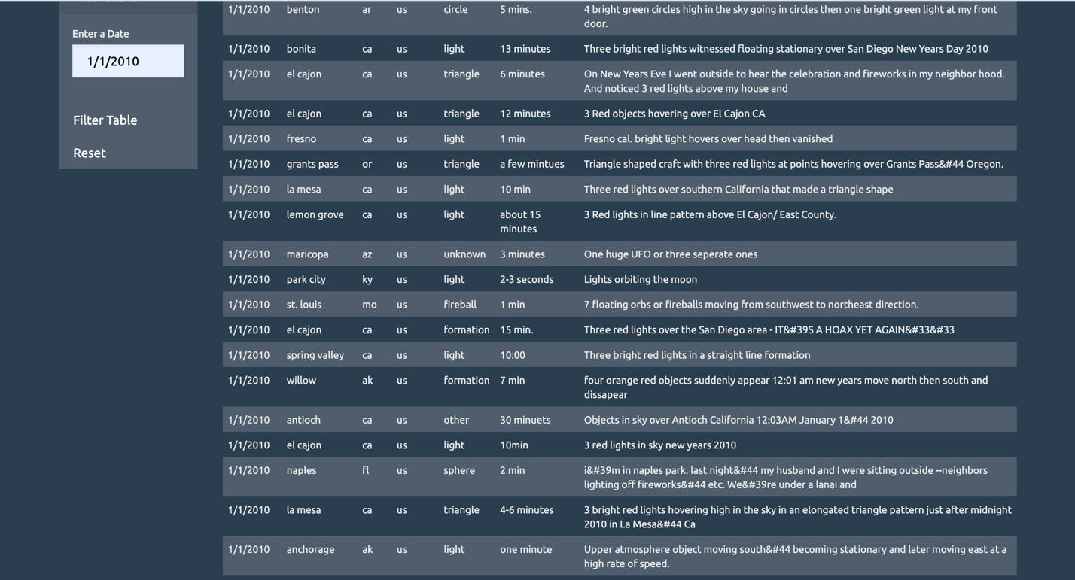

**Sketch:**

1. Homepage
   1. Visualization 3 (above) showing the Top 10 players in the world.
   2. Rotating
   3. Project description
2. Player Demographic page
   1. Visualization 1 (above) where users can find information about each player
3. Country Information page
   1. Visualization 2 (above) where users can visualize the distribution of the best players around the world. Inside this page, users can also choose a country and get more information about its players.
4. Data page
   1. Visualization 4 (above) where users can query the entire database using multiple filters.

* Additional:
  + Collapsible Navbar with links to each of the webpages, as well as a button for running the scrape function to collect new data
  + Use this as part of our logo (https://giphy.com/gifs/SportsManias-football-soccer-futbol-WvuTFk2IN7jxoLVDkP)

**Github Repository:**

https://github.com/blhawkins/theFootballers